Ingress and Egress

Ingress
Ingress = traffic coming INTO an application or network component. The browser's request is ingress traffic into your OpenShift application.
Ingress Traffic Egress example
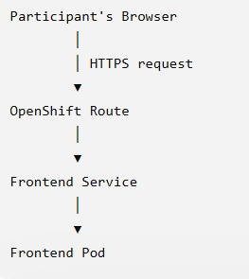
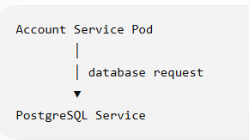

Egress
Egress = traffic going OUT from an application or network component.
The request leaving Account Service toward PostgreSQL is egress from Account Service.
Service-to-service traffic
This is where egress becomes important.
Suppose Account Service needs customer information.
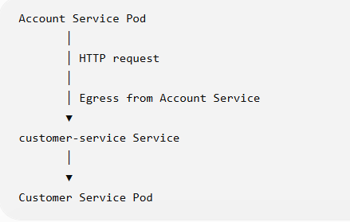

App Deployment

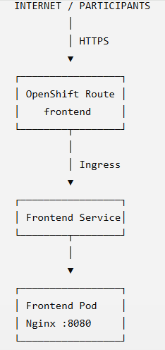
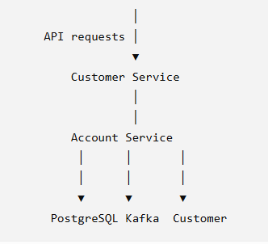

Complete Traffic flow
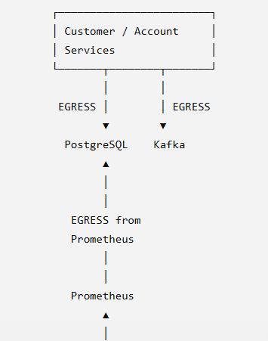
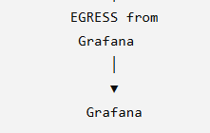
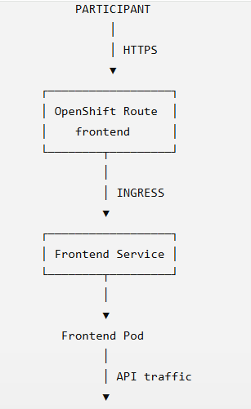

Frontend Egress configuration

apiVersion: route.openshift.io/v1
kind: Route
metadata:
name: frontend
spec:
to:
kind: Service
name: frontend
port:
targetPort: http
tls:
termination: edge
insecureEdgeTerminationPolicy: Redirect
This is the important part:
kind: Route
A Route creates an externally accessible URL.
For example, our frontend route becomes something like:
https://frontend-lakshmibv-dev.apps.rm2.thpm.p1.openshiftapps.com
Traffic flows:
Browser
|
| HTTPS
| INGRESS
v
OpenShift Route
|
v
Frontend Service
|
v
Frontend Pod

Route is the OpenShift entry point for external HTTP/HTTPS traffic.

Frontend ingress configuration
our frontend has:
kind: Service
metadata:
name: frontend
spec:
ports:
- name: http
port: 80
targetPort: 8080
Notice something important.
The container listens on:
8080
The Service exposes:
80
And the Route points to the Service:
Route
↓
Service port 80
↓
Pod port 8080
Internet
|
| HTTPS
v
Route
|
| HTTP
v
frontend Service :80
|
| targetPort 8080
v
Frontend Pod :8080
This is the ingress path into your frontend.
Targetport means
Expose the Service on port 80, but send the traffic to port 8080 on the Pod."

